 CHEMICAL ENGINEERING TRANSACTIONS  VOL. xxx, 2026 | A publication of  
The Italian Association
of Chemical Engineering
Online at www.cetjournal.it

Guest Editors: Marco Bravi, Antonio Marzocchella, Giuseppe Caputo
Copyright © 2026, AIDIC Servizi S.r.l.
ISBN 979-12-81206-xx-x; ISSN 2283-9216
Methodological Evaluation of Surface Tension Measurement Techniques for Commercial Surfactant Additives Relevant to Enhanced Oil Recovery Applications
Ditta Adrienn Gerbovitsª*, Roland Nagyª, Sándor Puskás^{b}
ªUniversity of Pannonia, Faculty of Engineering, 10. Egyetem St., HU-8200, Veszprém, Hungary,
^{b}MOL Plc, Group Oilfield Chemical Technologies, HU-6750, Algyő, Hungary
gerbovits.ditta.adrienn@mk.uni-pannon.hu
The transition toward a circular bioeconomy requires the development of sustainable surfactant systems suitable for industrial applications such as Enhanced Oil Recovery (EOR). Reliable characterization of surface properties represents a necessary step in surfactant screening prior to application-specific performance evaluation. This study presents a methodological comparison of pendant drop and spinning bubble tensiometry for the analysis of commercially available surfactant additives. Surface tension measurements were conducted in the concentration range of 0.01–15.0 g/L at 25 °C. Strong linear correlations were observed between the two techniques, with Pearson correlation coefficients between 0.973 and 0.978 and coefficients of determination above 0.94. The investigated additives reduced the surface tension of water (72 mN/m) to values below 30 mN/m, confirming their pronounced surface activity. The results demonstrate that spinning bubble tensiometry provides reliable trend-following capability and can serve as a rapid screening tool in surfactant development workflows. The validated methodology offers a robust experimental framework that can be extended to the future evaluation of sustainable surfactant systems.
  - Introduction
Surfactants play a key role in a wide range of industrial processes where modification of surface and interfacial properties is required. In the energy sector, Enhanced Oil Recovery (EOR) technologies rely on chemical agents capable of reducing capillary forces and improving the mobilization of trapped hydrocarbons. Oil–water interfacial tension therefore represents a critical parameter influencing oil displacement efficiency ( Liu, et al., 2025; Azis, et al., 2021). However, during early-stage surfactant evaluation, the characterization of air–liquid surface tension is commonly used as a practical indicator of surface activity and adsorption behavior (Rosen & Kunjappu, 2012).
Waste-derived feedstocks, such as waste cooking oil (WCO), have emerged as promising raw materials for the development of sustainable surfactant systems. Before newly synthesized surfactants can be evaluated for application-specific performance, reliable and reproducible characterization methods must be established to ensure accurate comparison between measurement techniques.
Standard tensiometric techniques such as the pendant drop and spinning bubble methods are widely used for determining surface tension (ST). The pendant drop method is commonly applied for air–liquid surface tension measurements, whereas spinning drop or spinning bubble techniques are frequently employed in low-tension regimes (Saad, Policova, & Neumann, 2011; Berry, Neeson, Dagastine, Chan, & Tabor, 2015; Torza, 1975). Despite their widespread use, systematic comparison of these methods under identical experimental conditions remains necessary to assess their agreement and practical interchangeability in surfactant screening workflows.
The present study focuses exclusively on air–liquid surface tension measurements of commercially available surfactant additives. The objective is to establish and validate a methodological framework by comparing the reliability and trend-following capability of spinning bubble tensiometry with the standard pendant drop method. This validation step provides a reproducible experimental baseline that may support future investigations of sustainable surfactant systems.
  - Materials and methods
Three commercially available surfactant additives were selected as reference compounds to ensure experimental reproducibility and standardized comparison between measurement techniques. The investigated materials included 2,4,7,9-tetramethyl-5-decyne-4,7-diol, its ethoxylated derivative, and dioctyl sulfosuccinate sodium salt (DOSS). All chemicals were used as received without further purification.
Aqueous solutions were prepared using deionized water (resistivity ≥ 18.2 MΩ·cm). Surfactant solutions were prepared gravimetrically at concentrations ranging from 0.01 to 15.0 g/L. Solutions were mixed using magnetic stirring for 30 minutes at ambient temperature and allowed to equilibrate for at least 24 hours prior to measurement to ensure complete dissolution and adsorption equilibrium. The physico-chemical properties of the investigated reference surfactants are summarized in Table 1. (Krishnan & Sprycha, 1999; Patel, et al., 2021)
Table 1.: Physical and chemical properties of the investigated surfactants
Properties/Sign of surfactants | Surfactant 1 | Surfactant 2 | Surfactant 3
Name | 2,4,7,9-Tetramethyl-5-decyne-4,7-diol,  mixture of (±) and meso | 2,4,7,9-Tetramethyl-5-decyne-4,7-diol  ethoxylate | Dioctyl sulfosuccinate sodium salt
CAS-No. | 126-86-3 | 9014-85-1 | 577-11-7
Mol. weight (g/mol) | 226,36 | 288,4 | 444,56
Color | white | amber | white
Odor | odorless | odorless | odorless
Melting/freezing point (°C) | 42-44 | -90 | 173-179
Water solubility | 1,7 g/L at 20 °C | 2,89 g/L at 25 °C | 8,17 g/L at 20 °C
Density | 0,882 g/cm³ at 20 °C | 1,04 g/cm³ at 25 °C | 1,146 g/cm³ at 27,4 °C

These additives are known for their rapid adsorption at interfaces and are commonly used in applications requiring efficient surface tension reduction. Their ability to rapidly orient at interfaces makes them ideal for treating low-energy surfaces often encountered in reservoir rocks and industrial coatings.
Analytical methods
The characterization of surface properties was conducted using two distinct tensiometric techniques to evaluate their applicability and reliability in surfactant analysis. All measurements were performed at 25 ± 0.5 °C under atmospheric pressure.
    - Pendant Drop Method (Reference Method)
Surface tension measurements were conducted using an FTA 1000 B optical tensiometer (First Ten Ångstroms Inc., USA). The droplet profile was captured using a high-resolution CCD camera and analyzed via instrument-specific software based on the Young–Laplace equation ( Berry, Neeson, Dagastine, Chan, & Tabor, 2015; Esfandiarian, Maghsoudian, Davarpanah, Tamsilian, & Kord, 2022; Saad, Policova, & Neumann, 2011).
Droplets were generated using a stainless-steel needle. Prior to each measurement series, the instrument was calibrated using deionized water, verifying a surface tension value of 72.0 ± 0.5 mN/m at 25 °C. Each concentration was measured in triplicate, and reported values represent the arithmetic mean.
Figure 1. shows the operating principle of the pendant drop device.
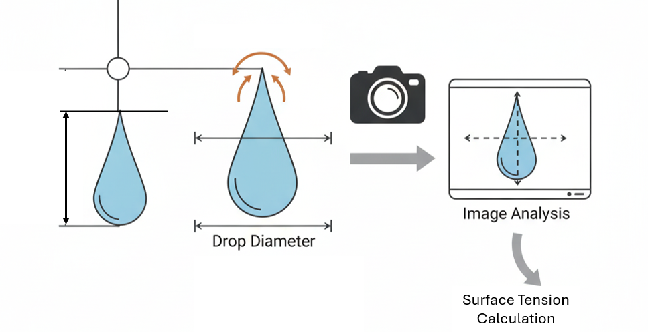
Figure 1. Operation principle of the pendant drop method
    - Spinning Bubble Method
Surface tension measurements under rotational conditions were performed using a KRÜSS SDT spinning drop tensiometer (KRÜSS GmbH, Germany). Although the instrument is primarily designed for liquid–liquid interfacial tension measurements, in the present study it was operated in an air–liquid configuration by introducing a small air bubble into the aqueous surfactant solution.
The capillary tube was rotated at a constant angular velocity of 3500 rpm. The bubble diameter was recorded optically, and surface tension values were calculated using the classical spinning drop relationship as described by Torza (1975). Temperature was maintained at 25 ± 0.5 °C using the integrated temperature control system. Each concentration was measured in triplicate, and the reported values represent the arithmetic mean (Torza, 1975). Figure 2. shows the operating principle of the spinning bubble device.
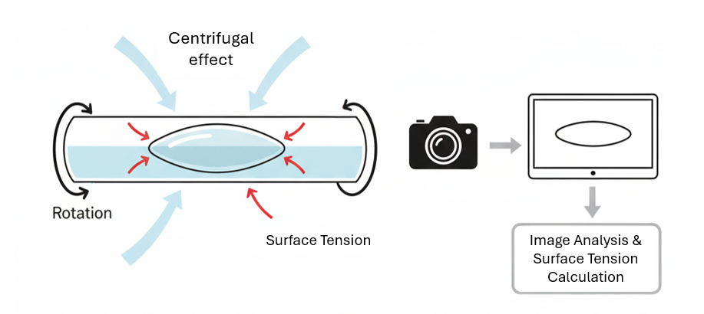
Figure 2. Operation principle of the spinning bubble method
  - Results and discussion
Comparison of tensiometric methods
The surface tension (ST) of the three surfactants was measured across a wide concentration range from 0.01 g/L to 15.0 g/L. This range was selected to evaluate the concentration-dependent behavior of the systems and to assess the trend-following capability of the spinning drop method relative to the pendant drop reference technique in both pre- and post-micellar regions. As shown in Figures 3–5, both methods demonstrate the characteristic decrease in surface tension with increasing surfactant concentration. The concentration range associated with micellization can be identified from the change in slope of the ST–concentration curves, although minor systematic deviations between the two techniques are observed in absolute values (Myers, 2005).
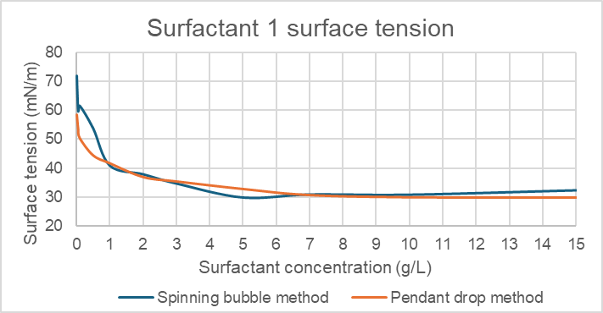
Figure 3: Surface tension vs. concentration for Surfactant 1 measured by pendant drop and spinning drop methods.
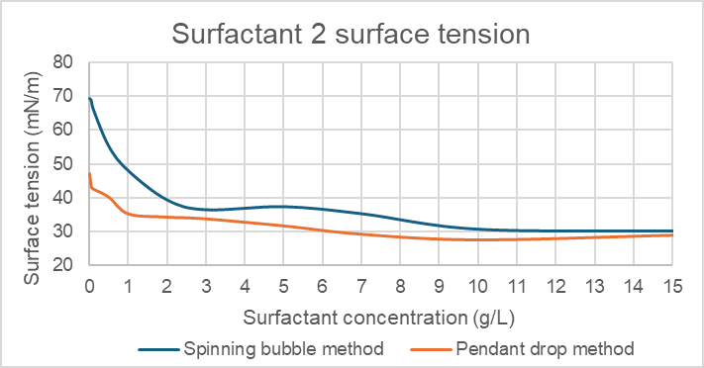
Figure 4: Surface tension vs. concentration for Surfactant 2 measured by pendant drop and spinning drop methods.
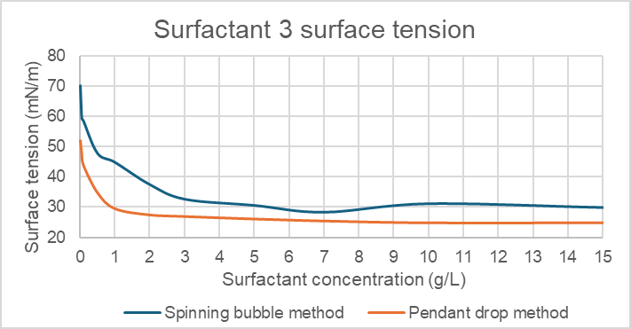
Figure 5: Surface tension vs. concentration for Surfactant 3 measured by pendant drop and spinning drop methods.
For all three surfactants, the Pearson correlation coefficients (r) indicate a strong linear association between the two measurement principles, with all values exceeding 0.97. The corresponding coefficients of determination (R² > 0.94) confirm that a substantial proportion of the variance in one method is linearly related to the other. The statistical parameters of this relationship are summarized in Table 2. It should be noted, however, that correlation analysis reflects trend similarity rather than methodological equivalence, and therefore does not alone demonstrate full agreement between the two techniques.
Table 2: Statistical evaluation of the correlation between pendant drop and spinning bubble measurements for the reference surfactants.
Surfactants | Pearson correlation (r) | Coefficient of Determination (R²) | Mean Absolute Deviation (mN/m)
Surfactant 1 | 0.978 | 0.957 | 4.53
Surfactant 2 | 0.973 | 0.946 | 11.29
Surfactant 3 | 0.976 | 0.952 | 9.81
Analysis of deviations and method reliability
While the concentration-dependent trends were highly consistent across the investigated range, systematic absolute deviations were observed between the two techniques. For Surfactant 2 and Surfactant 3, the mean absolute deviation values reached 11.29 mN/m and 9.81 mN/m, respectively. These differences indicate the presence of a systematic measurement bias rather than random error.
The observed offsets can be attributed to the distinct physical principles governing the two methods. The pendant drop technique evaluates a static droplet profile under gravitational deformation, whereas the spinning drop configuration involves centrifugal forces that influence bubble geometry and interfacial stability. As a result, small but consistent differences in absolute surface tension values are expected.
Although the high R² values (all > 0.94) demonstrate strong linear association between the methods, this does not imply full interchangeability. Instead, the spinning drop method reliably captures relative concentration-dependent trends. The relative standard deviation (RSD) of the spinning drop measurements remained below 10%, indicating acceptable repeatability for comparative screening purposes. Therefore, the spinning drop configuration can be considered a complementary tool for rapid surfactant evaluation rather than a direct substitute for pendant drop measurements of absolute surface tension values.
  - Conclusions
This study evaluated the applicability of spinning drop tensiometry as a rapid characterization tool for commercially available surfactant additives in comparison with the standard pendant drop method. Based on experimental results obtained in the concentration range of 0.01–15.0 g/L, strong linear correlations were observed between the two techniques (Pearson r = 0.973–0.978; R² > 0.94), confirming consistent trend-following behavior.
Systematic absolute deviations were identified between the methods, indicating the presence of measurement bias arising from differences in their underlying physical principles. Consequently, the two techniques should not be considered fully interchangeable for reporting absolute surface tension values. Nevertheless, the spinning drop configuration demonstrated acceptable repeatability and reliable detection of concentration-dependent behavior, including identification of the micellization region.
The findings support the use of spinning drop tensiometry as a complementary screening tool within surfactant evaluation workflows. The validated methodological framework provides a reproducible experimental baseline that can facilitate future investigations of sustainable surfactant systems.
Nomenclature
Symbols
c – concentration, g/L
r – Pearson correlation coefficient, -
R² – Coefficient of determination, -
SD – Standard deviation, mN/m
Greek symbols
γ - Surface tension, mN/m
Abbreviations
EOR – Enhanced Oil Recovery
ST – Surface Tension
RSD – Relative Standard Deviation
Acknowledgments
Prepared with the professional support of the Co-operative Doctoral Program of the University Research Scholarship Program of the Ministry of Culture and Innovation financed from the National Research, Development and Innovation Fund. (Hungary)
References
Azis, M. M., Febrina, F., Anindia, I., Darmawati, G. A., Fenyka, D. A., Purwono, S., & Rochmadi, R., 2021., Development of Ultralow Interfacial Tension Lignosulfonate from Kraft Black Liquor for Enhanced Oil Recovery. Journal of Engineering and Technological Sciences, 53(2), 210210.
Berry, J., Neeson, M., Dagastine, R., Chan, D., Tabor, R., 2015, Measurement of surface and interfacial tension using pendant drop tensiometry, Journal of Colloid and Interface Science, 454, 226-237.
Esfandiarian, A., Maghsoudian, A., Davarpanah, A., Tamsilian, Y., Kord, S., 2022, Developing a novel procedure in utilizing pendant drop method for determination of ultra-low interfacial tension and surface tension in near-miscibility conditions, Journal of Petroleum Science and Engineering, 215, 110607.
Krishnan, R., Sprycha, R., 1999, Interactions of acetylenic diol surfactants with polymers: Part 1. Maleic anhydride co-polymers, Colloids and Surfaces A: Physicochemical and Engineering Aspects, 149, 355–366.
Liu, P., Li, X., Li, H., Liu, S., Wang, J., Zhang, P., 2025, Application and Synthesis of Gemini Surfactant in Heavy Oil Development, ACS Omega, 10, 9, 8832-8842.
Myers, D., 2006, Surfactant Science and Technology, 3rd ed., Wiley, Hoboken.
Patel, A., Ray, D., Khimani, M., Parikh, J.K., Parekh, P., Patel, V.I., Aswal, V.K., Bahadur, P., 2021, Influence of Surfynol® 104 on aggregation behaviour of Triton X-100 micelles, Journal of Molecular Liquids, 332, 115878.
Rosen, M.J., Kunjappu, J.T., 2012, Surfactants and Interfacial Phenomena, 4th ed., Wiley, Hoboken.
Saad, M. S., Policova, Z., Neumann, A. W., 2011, Design and accuracy of pendant drop methods for surface tension measurement, Colloids and Surfaces A: Physicochemical and Engineering Aspects, 384(1), 442-452.
Torza, S., 1975, The rotating-bubble apparatus, Review of Scientific Instruments, 46(6), 778–783.

